Grant Grummer

8/24/2020

Starlite Installation & Setup

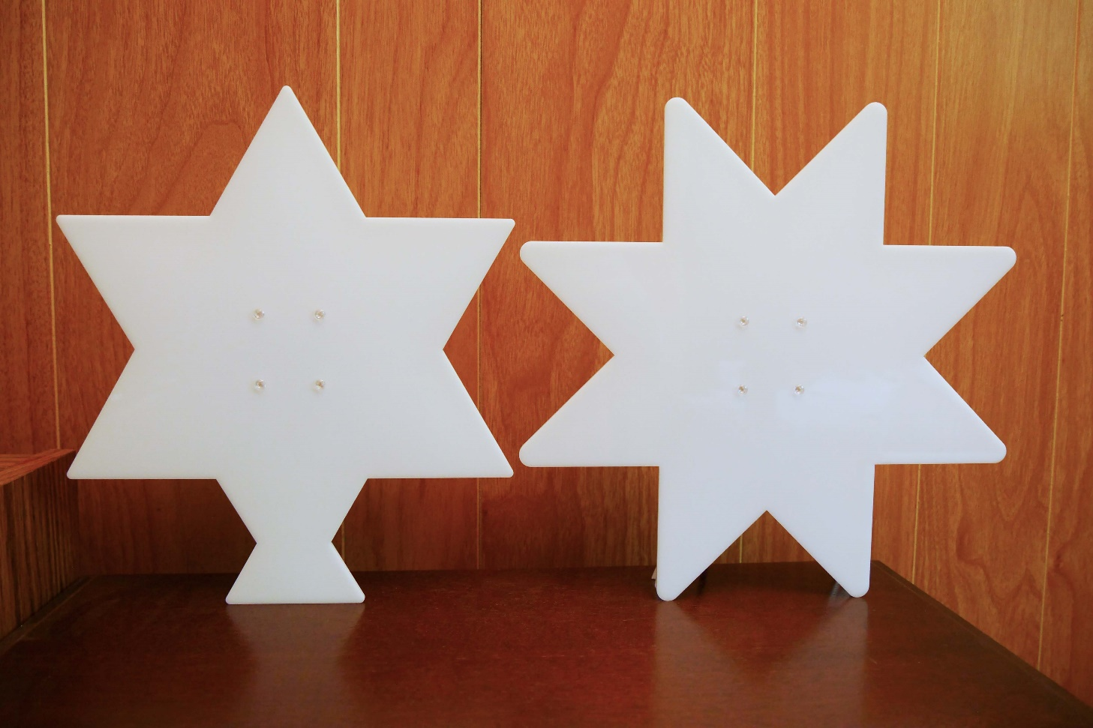

Revision: A.0

Table of Contents

Introduction 1

Build Tools 1

Creating a Project 1

Download Starlite Files 3

Next Steps 4

Quick Custom Displays 4

Altering the Code 4

Adding Files to The Project 4

Select a synthesis tool 4

Add Design Files 5

Add Constraint Files 5

Building the Design 6

# Introduction

Welcome to the Starlite project setup. Whether you’re planning to build the 6- or 8-point star, the follow information will help you on your way. This document covers Windows installations only.

# Build Tools

The design was built using the Lattice Semiconductor iCEcube2 platform. There are other tools one could use, but that would require significant changes to the supplied code. iCEcube2 is free and is available on the Lattice website at:

<http://www.latticesemi.com/Products/DesignSoftwareAndIP/FPGAandLDS/iCEcube2>

You’ll find useful documentation on that web page. The “iCEcube2_install_overview” document has important installation and license information. A license is required to run iCEcube2. The link to obtaining a license is also at the above website. Follow the license link. You’ll be asked to sign in to your account. If you don’t have one, you’ll need to create by selecting the “Create Account” link.

Once a license is obtained, download and install iCEcube2. In order to use the supplied Windows batch files as is, install iCEcube2 into the following path: “C:\Tools\lscc”. Otherwise one can modify the batch files with a different install path.

# Creating a Project

Start the iCEcube2 software. The iCECube2 main window appears, as shown in Figure 1.



Figure 1: iCEcube2 Main Window

To create a new project, choose File > New, or click the Create a New Project icon as shown in Figure 1. This will launch the New Project Wizard, as shown in Figure 2. Make the changes indicated (in Figure 2) to the Project, Device and IO Bank Voltage sections.

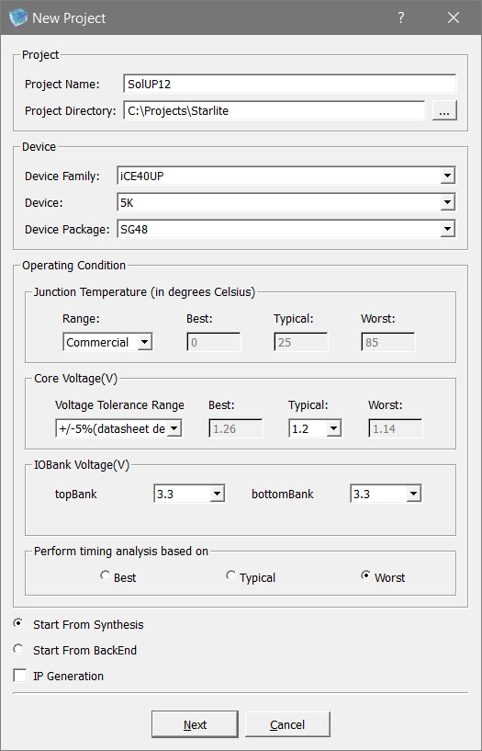

Figure 2: New Project Wizard

Click Next to display the Add Files dialog box.

Select Finish (we’ll add the files later).

# Download Starlite Files

The Starlite files are located in GitHub. In order to download the files, one clones the directories using “[GitHub Desktop](https://desktop.github.com/)”. Once GitHub Desktop is installed, the Starlite project is located at:

<https://github.com/ggrummer/Starlite>

Place the following folders in “..Starlite\ SolUP12\SolUP12_Implmnt\sbt”:

* constraint
* netlist
* outputs
* patterns
* rtl
* TestBenchs

The rest of the folders should be placed in the “Starlite” directory.

# Next Steps

## Quick Custom Displays

A quick way to get started with Starlite is to make your own custom displays. If that’s the plan, there’s no need to continue with the installation. If desired one can always continue at a later time. Refer to the “Starlite User’s Manual” section on “Quick Custom Displays” for further instructions.

## Altering the Code

If the plan is the alter the code, iCEcube2 will need to know where to find the code and constraints. The following sections will cover how to this.

# Adding Files to The Project

## Select a synthesis tool

The project was built using the “Lattice LSE” synthesis engine. In the project panel, on the left side of the iCEcube2 window, right click on “Synthesis Tool” and select “Select Synthesis Tool…”. Select “Lattice LSE” and click OK.

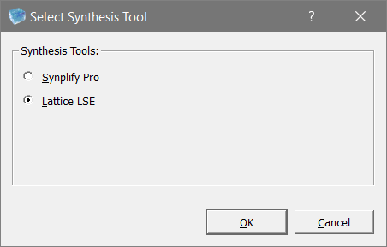

Figure 3: Selecting the Synthesis Tool

## Add Design Files

Under “Synthesis Tool” is “Add Synthesis Files” and under that are “Design Files” and “Constraints Files”. Right click on “Design Files” and select “Add Files…”.

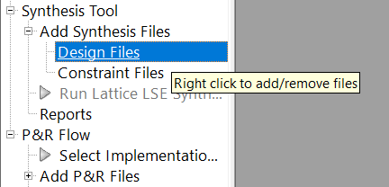

Figure 4: Where to Add Design Files

Add all the files in the “rtl” directory by selecting the “>>>” button.

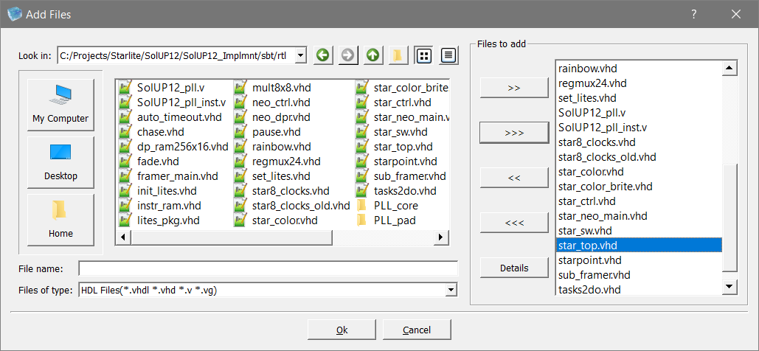

Figure 5: Add the Files

The top-level design file must be at the bottom of the list. There’s no straight forward way to do this so select “star_top.vhd” in the right most “Files to add” window. Select “<<” to remove it. Now select “star_top.vhd” in the right most window. Select “>>” to re-add it. Now it will show up in the bottom of the list. Now select “Ok”.

## Add Constraint Files

Right click on “Constraints Files” and select “Add Files…”. Add “star.sdc” from the “constraint” directory by selecting “>>” to add it. Select “Ok”.

Right click on “Add P&R Files” and select “Add Files…”. Add “star.pcf” from the “constraint” directory by selecting “>>” to add it. Select “Ok”.

# Building the Design

Instructions for building the design are covered in the “Starlite User’s Manual”. Refer to the “Run Synthesis” section to start the build.